SEEM Collaborative Fall Happenings

November, 2013

Ripley Students and Staff FALL into Learning,

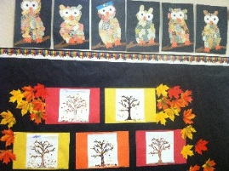
Students in all six classrooms have been busy since September learning about autumn in New England; writing about themselves and important people in their lives through creative writing and poetry; studying rocks and minerals; exploring different kinds of art; and learning about and understanding each other’s differences in health class. All students enjoyed fall field trips to Applecrest Farm in NH, where they learned about the work it takes to run an apple orchard; how apple cider is made; how important bees are to the environment; and how apple trees produce the oxygen we breathe.
Teachers, Curriculum Advisors and Administrators have implemented Wilson Reading FUNdations into our balanced literacy program for students at a K to 3 reading level. We are using literature circles for students at the 4th/5th grade level. Look for your children to “tap” sounds and “scoop” phrases when reading and writing at home!

Have you “HURD” the Music?
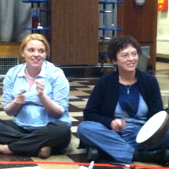
Mike Simonelli began teaching music to students in E1, E2 and E3 on Wednesday October 16th and will be at Hurd @ Ripley on Wednesday afternoons for the remainder of the school year. He will alternate between the three younger classrooms and the three older classrooms (E4, E5 and E6), exposing students to different types of music and instruments. On September 9th, Mike conducted some activities with the staff to show what sorts of skills and activities he will use with students. Staff had a lot of fun playing different instruments and expressing our musical talents.

Sold a Sweet Amount of Pies, and More!
- We just wrapped up our first fundraiser of the year and sold 187 pies!! Thanks to all who supported our efforts by selling and/or buying pies!!
- 50% of our families attended our fall open house and 11 parents attend our first PAC meeting of the year!
- We look forward to sharing Thanksgiving brunch with family and friends on Wednesday November 27th and to seeing lots of people come to our Holiday Fair on Friday night December 13th. We are gladly accepting donations to our silent auction and raffle. Please donate items by calling and speaking with Marlene.

Beebe School STEPS Out!

On October 29, Beebe School students walked and ran to raise funds for health and wellness programs at our school. Students had a great time running the make-shift track, with music to pump them up and parents on the sideline to cheer them on! Over $3500 was raised to support health and wellness programs at the Beebe School.
Thank you to our corporate sponsors and donors: Beebe School OTs and PTs, Bruegger's Bagels, Flawless Auto Detailing, Home Trends, J&F Construction, Kowloon, Marathon Sports, North Shore Physicians Group, Shaw's, Starbucks, The T-Stop and Tonneson + Co. The Beebe Schools partnered with Action for Healthy Kids, a non-profit organization, to provide the online fundrasing system and program support as part of their Team Healthy Kids: School Runs program. Donations are still being accepted online at: http://www.firstgiving.com/fundraiser/TLCBeebe/seemsteps.

DHOH Students Sing and Sign

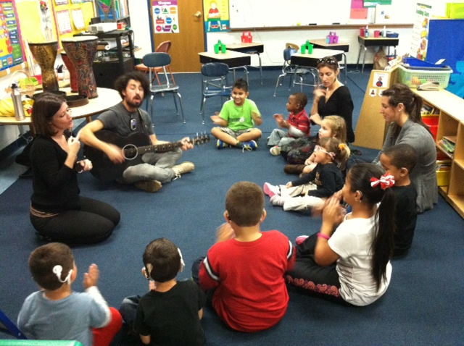

SEEM Prep Recognizes Rasheid

While all of our students at Seem Prep demonstrate ongoing success, we would like to share a few words in recognition of one in particular. For all who have worked with Rasheid over the years, witnessing his growth and development has been a source of incredible pride and joy.
Rasheid’s early days focused on building character, positive commitment, and personal responsibility. Each new step led him down the path of independence towards his current position of working alone in our community at a local Fitness Center and Market Basket. Aside from those amazing achievements, however, Rasheid’s greatest accomplishment reaches far beyond…today he is a friend, a mentor and a man with a bright future lying just ahead.

Middle School Happenings
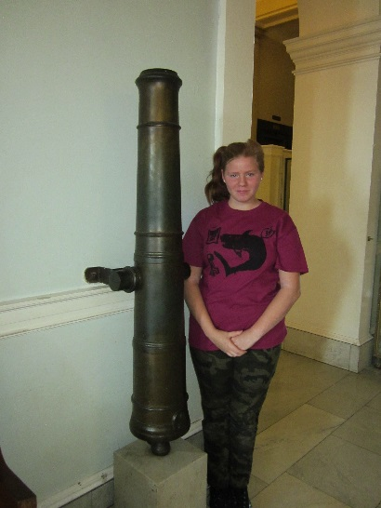
- SEEM Middle School welcomes our new Occupational Therapist, Suzanne Rappaport. During her groups, Suzanne showed students how to use a silk screen. Students were able to co-design T-shirts for their classroom.

- In Valerie’s class, students built and decorated bird houses.

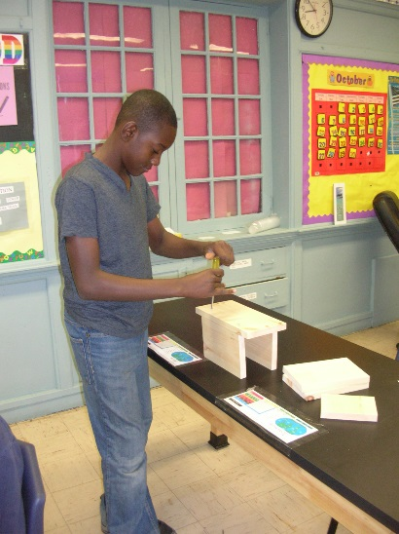
- This month, students in Andrea/Laura’s Social Skills group are organizing a food drive. They will deliver goods and volunteer at the Merrimack Valley Food Bank.

- Our Cookie Dough Fundraiser is underway! Order forms and information were sent home with students. Your help is always appreciated.

- School pictures will be taken on November 14. Order forms from Geskus Photography will be sent home the week before. A picture re-take day is scheduled for December 4.

Campus Academy/Community College Dual Enrollment Program

Students at Campus Academy High School are eligible to participate in a dual enrollment program with local community colleges and technical training schools. The schools that partner with SEEM Campus Academy for dual enrollment at this time are:
- Bunker Hill Community College
- North Shore Community College
- Middlesex Community College
- Northern Essex Community College
- Benjamin Franklin Institute
- Mass Bay Community College
Students who participate in dual enrollment take one or two colleges classes per semester while completing their high school requirements. The protocol for dual enrollment is that all students are required to take an Accuplacer Assessment to measure English and math skills.
Participating in dual enrollment and a school to work program allows students to develop and use skills that promote independence. Students participate in travel training to and from college, and they receive guidance and support both at Campus Academy and at the college they attend. Students learn to navigate college as independent college students.

